**Initial number of products:**

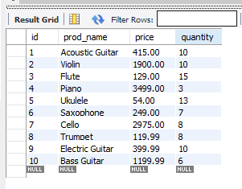

**When bamazon.js is run:**

1. **Displays the products and inquire the customer about the ID of the product**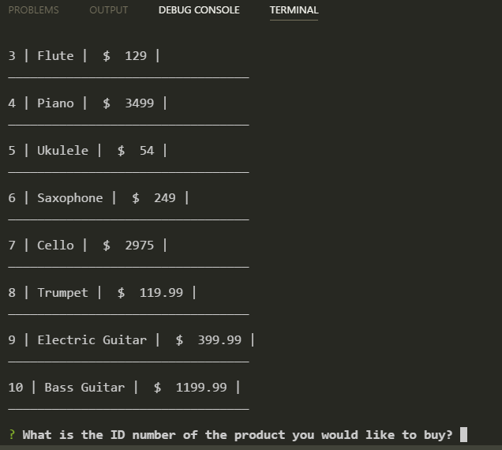

2. After inquiring the customer, it fulfill the order if there is enough products required. Also updates the quantity of the product on the database

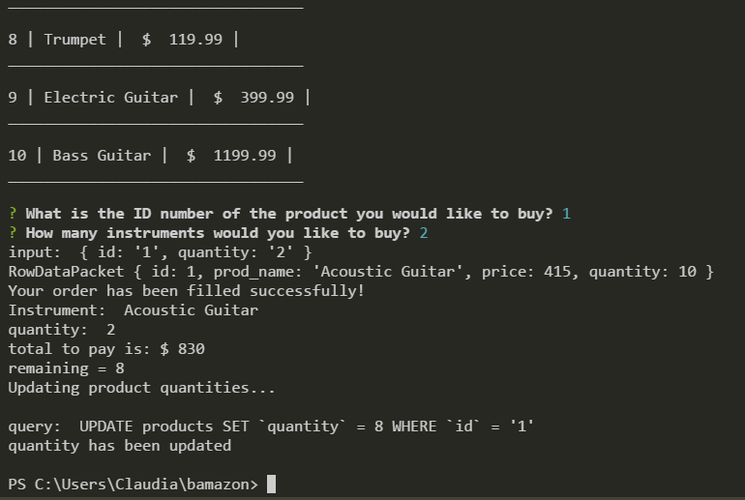

4. If there is not enough products

